Krishi Mitr: Smart Farm Aid Robo Car System

1. Introduction
Agriculture is evolving with the integration of modern technologies such as Artificial Intelligence (AI), Internet of Things (IoT), and Robotics. However, most farmers still rely on traditional methods, which are labor-intensive and lack precision.
KrishiMitr is designed as a smart autonomous/semi-autonomous farming assistant that can:
- Navigate through fields
- Monitor crop health
- Analyze plant diseases using AI
- Provide real-time environmental data
This system aims to bring precision agriculture to small and medium-scale farmers at a low cost.

2. Problem Statement (Deep Explanation)

Current Issues in Farming:
- ❌ Manual inspection takes time and is not scalable
- ❌ Diseases are detected too late → crop loss
- ❌ Water usage is not optimized
- ❌ No real-time decision-making tools
- ❌ Farmers lack access to smart technologies

Impact:
- Reduced yield
- Increased cost
- Inefficient resource usage
👉 KrishiMitr solves these by combining automation + intelligence + real-time monitoring

3. Objectives (Technical)
- Design a mobile robotic platform for farm traversal
- Implement sensor fusion system (soil + environment)
- Develop deep learning model (PyTorch-based) for disease detection
- Enable remote monitoring and control (Flask + App)
- Build scalable architecture for future autonomous farming

4. System Architecture (Detailed)
KrishiMitr follows a 3-layer architecture:

1. Hardware Layer
- Sensors + Camera + Motors + Raspberry Pi

2. Processing Layer
- Data processing (Python)
- AI inference (PyTorch model)
- Server (Flask API)

3. Application Layer
- Mobile App
- Web Dashboard

5. Block Diagram
Here’s how your system looks conceptually:

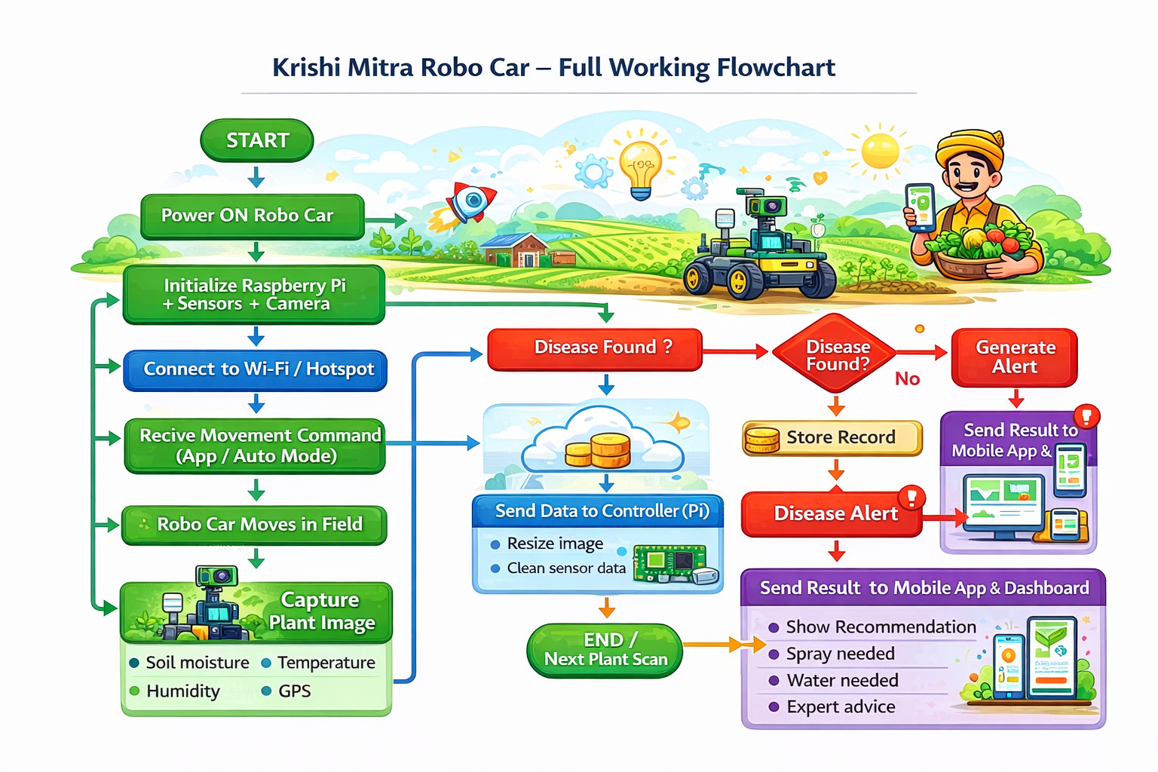

Block Flow Explanation:
- Sensors Layer
  - Soil Moisture Sensor
  - Temperature & Humidity Sensor
- Vision System
  - Camera captures plant images
- Processing Unit (Raspberry Pi)
  - Collects sensor + image data
  - Runs Python scripts
  - Sends image to AI model
- AI Model (PyTorch)
  - Classifies plant as:
    - Healthy
    - Diseased
  - Returns prediction
- Communication Layer (Flask API)
  - Sends data to app/dashboard
  - Receives control commands
- User Interface
  - Mobile App
  - Web Dashboard
- Control System
  - Motor driver controls movement

6. Hardware Components (Advanced Explanation)

Raspberry Pi 4B
- Acts as edge computing device
- Runs:
  - Flask server
  - AI inference
  - Sensor scripts

Sensors
- Soil moisture → Analog/Digital signal
- DHT22 → Digital signal

Camera
- Captures RGB images
- Used as input to AI model

Motor Driver (L298N)
- Converts low-power signals into motor control
- Supports direction + speed control

7. Software & Technologies

1. Backend (Flask)
- REST API:
  - /move → control robot
  - /data → sensor data
  - /image → latest image

2. AI Model (PyTorch) ✅ (Important Addition)
We use PyTorch deep learning framework for plant disease detection.

Model Workflow:
- Image input from camera
- Preprocessing:
  - Resize
  - Normalize
- Pass through CNN model
- Output:
  - Healthy / Diseased

Why PyTorch?
- Easy to train and debug
- Faster prototyping
- Strong community support
- Compatible with Raspberry Pi

Example Pipeline:
- Dataset → Training → Model (.pt file) → Deployment on Pi

3. Mobile App (Flutter / Android)
- Sends commands
- Displays:
  - Sensor data
  - Images
  - Disease results

4. Web Dashboard
- Real-time monitoring
- Graphs + alerts
- Remote access

8. Working Principle (Detailed Flow)

Step-by-Step Operation:
- User starts system
- Robo car moves via:
  - App control OR
  - Predefined path
- Sensors continuously collect:
  - Soil moisture
  - Temperature
  - Humidity
- Camera captures plant images
- Raspberry Pi:
  - Processes sensor data
  - Sends image to PyTorch model
- AI Model:
  - Detects disease
  - Outputs prediction
- Data sent to:
  - Mobile app
  - Web dashboard
- User:
  - Monitors data
  - Controls movement
  - Takes action

9. Key Features (Enhanced)
- Smart robo car navigation
- AI-based disease detection (PyTorch)
- Real-time monitoring system
- Remote access via app/web
- Image processing + classification
- Expandable system architecture

10. Advantages (Technical)
- Edge AI processing (low latency)
- Reduces dependency on cloud
- Scalable and modular
- Affordable for farmers
- Improves productivity

11. Limitations
- Limited processing power of Raspberry Pi
- Requires training dataset for AI
- Battery constraints
- Network dependency for remote control

12. Future Upgradations (Advanced)

🚀 Autonomous Navigation
- GPS + Path planning
- SLAM (Simultaneous Localization and Mapping)

🌱 Smart Spraying System
- Detect disease → Spray automatically

🧠 Advanced AI
- Multi-class classification
- Pest detection
- Yield prediction

☁️ Cloud + IoT Integration
- Data storage
- Analytics dashboard

🔊 Voice + AI Assistant
- Voice commands in Hindi/English

🔋 Solar Integration
- Long battery life
- Sustainable system

13. Applications
- Precision agriculture
- Smart irrigation systems
- Crop monitoring automation
- Research and development

14. Conclusion (Strong Version)
KrishiMitr represents a next-generation smart farming solution by integrating AI (PyTorch), IoT, and robotics into a single platform.
It empowers farmers with:
- Real-time insights
- Early disease detection
- Automated monitoring
With future upgrades, it can evolve into a fully autonomous intelligent farming system, significantly improving agricultural efficiency and sustainability.

